**Enterprise Access Security form (ESG Approval Guide)**



The online security form will be completed by the employee’s line manager or their delegate. An email will be sent to the employee and their line manager to acknowledge that the form has been submitted.

All forms will go to a designated finance team for approval (see Appendix 1 for approved authorisation workflow group by department).

If HRIS access is requested it will then go to the designated HR group for approval (see Appendix 1).

If either approver is not satisfied with the contents of the form it will be rejected or cancelled.

Once the form is approved as per the workflow above it will reach the ESG Security email group.

You will receive an email as shown below, with an attachment of the Security form and a link to the approval screen.

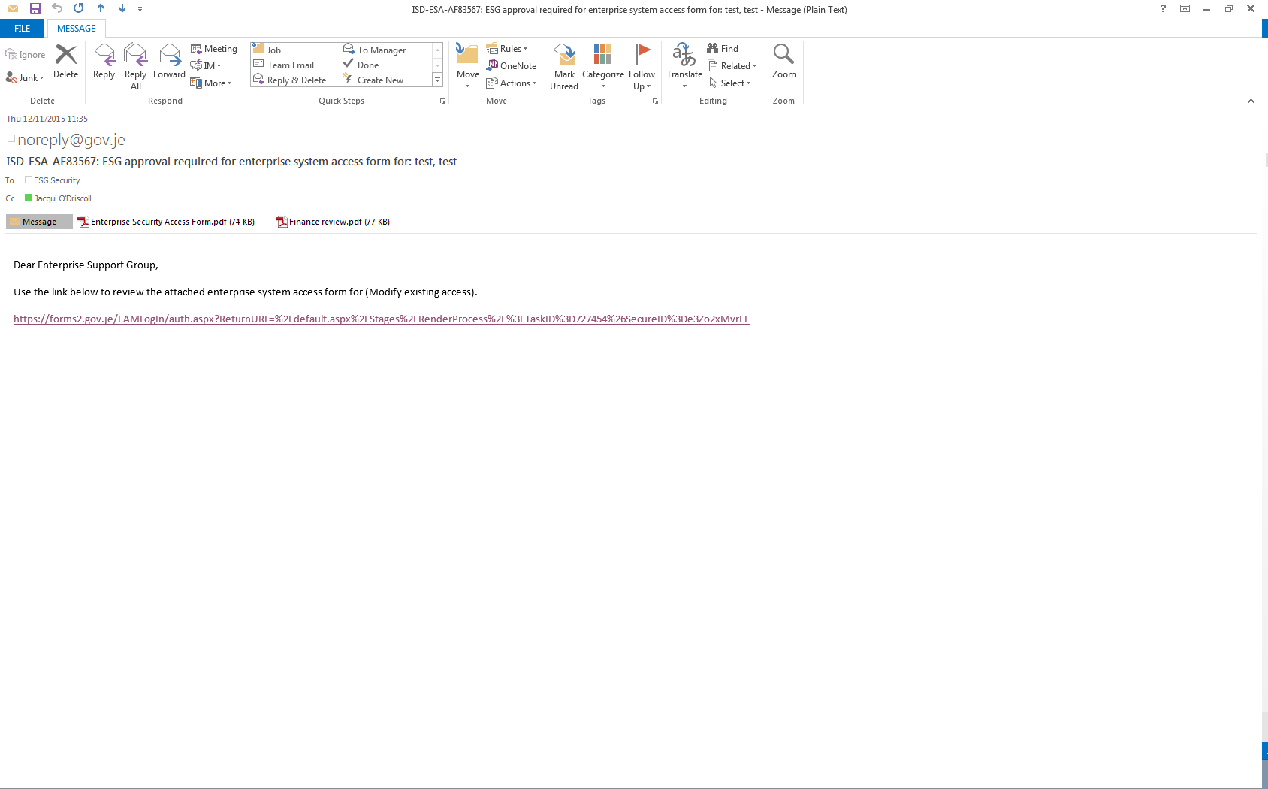

The attachment as shown below will display the access the user requires, please review the access and decide whether the request is correct.

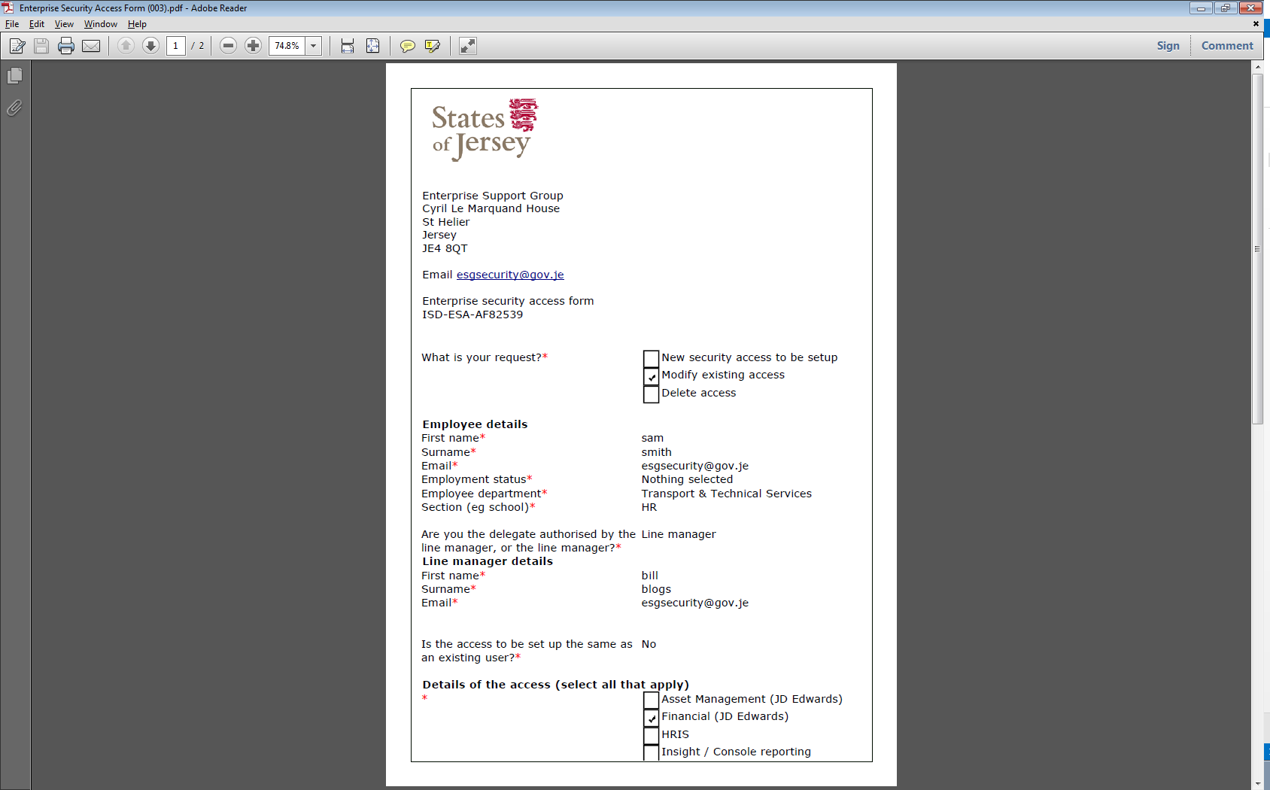

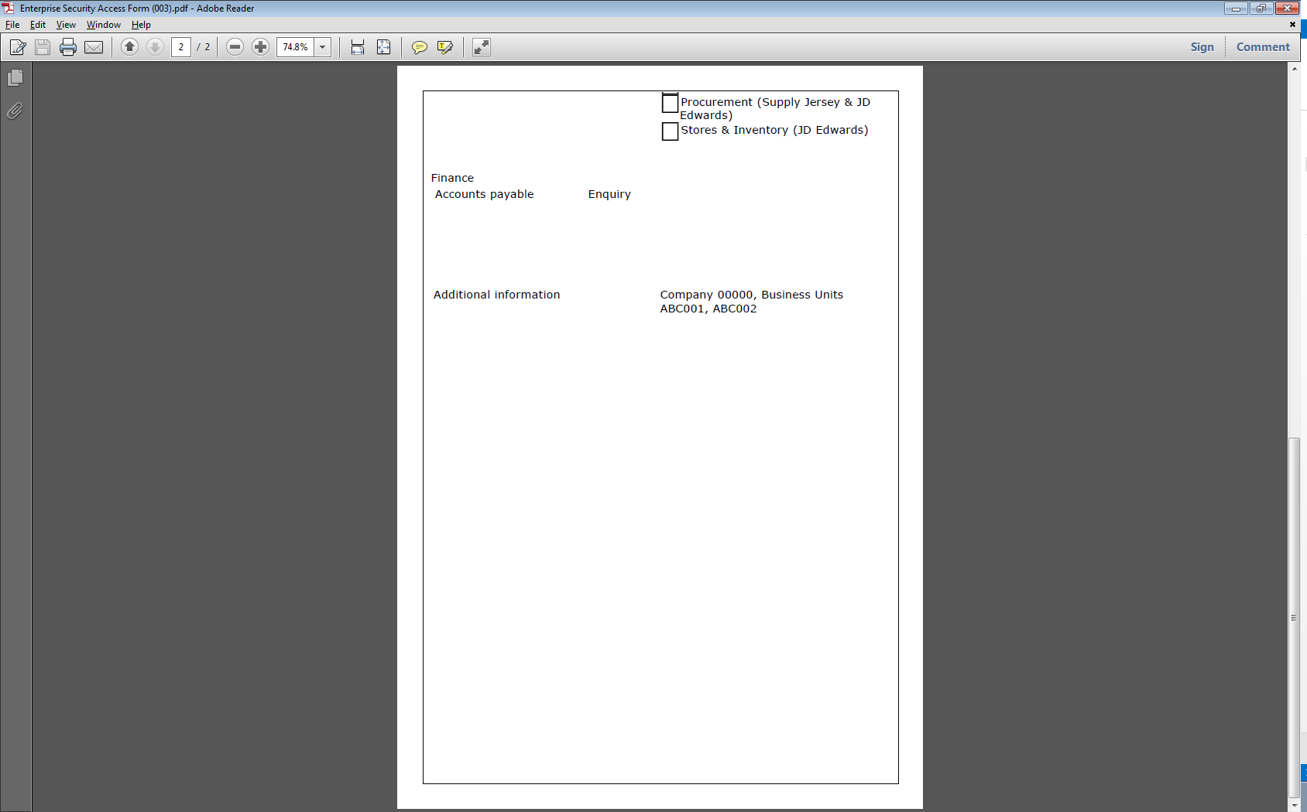

The link will take you to the approval page as shown below.

Please note that the approval page includes the request details and Employee name (eg: Modify existing access, test test).

The Name and Email fields are populated with the details of the person who clicked on the link.

If you agree with the security access request, select ‘Yes’ (as shown below) then ‘Next’.

A comment maybe entered in the Comments field if required to further clarify a Yes or No action.

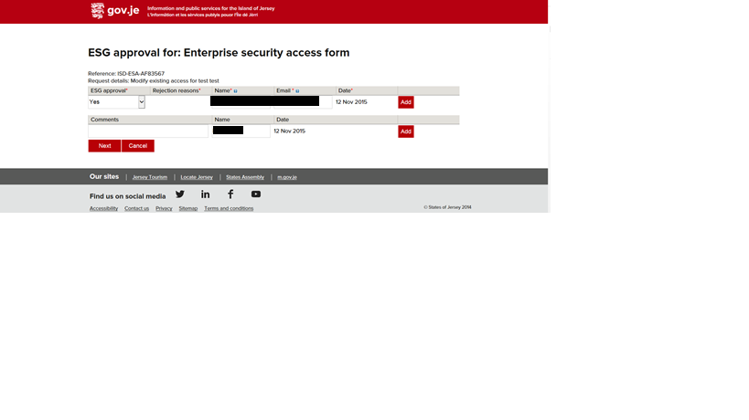After clicking ‘Next’ to the screen above, enter the UserID and Security Role and any other relevant information (as shown below).

This will then send an email to the user which includes their JDE user id.

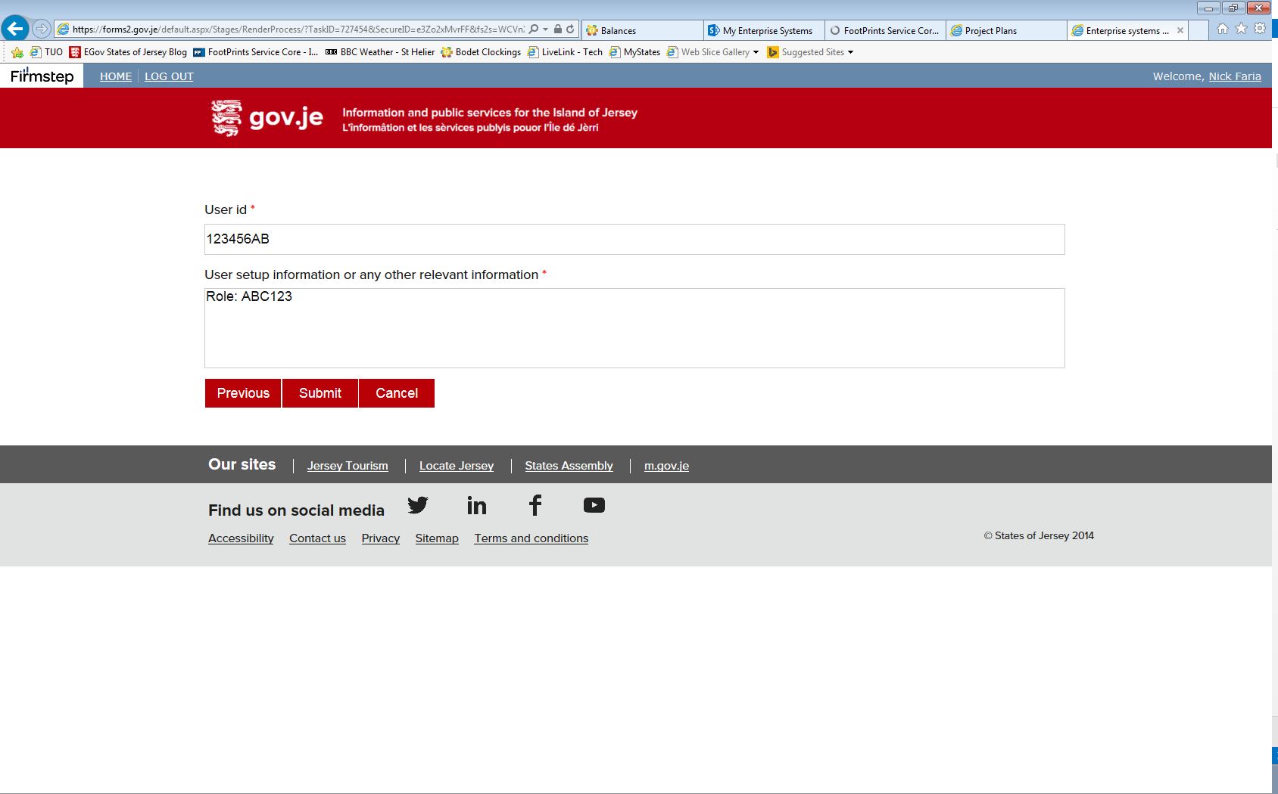

If you do not agree with the security access request, select ‘No’ (as shown below). You will need to choose a rejection reason (and add a comment below).

‘**Query on information provided**’ will send the form back to the Line manager / delegate (including your comments).

‘**Request cancelled**’ will end the form process without notification (you would need to contact the Line manager / delegate and advise why the form was cancelled).

A comment maybe entered in the Comments field if required to further clarify a Yes or No action.

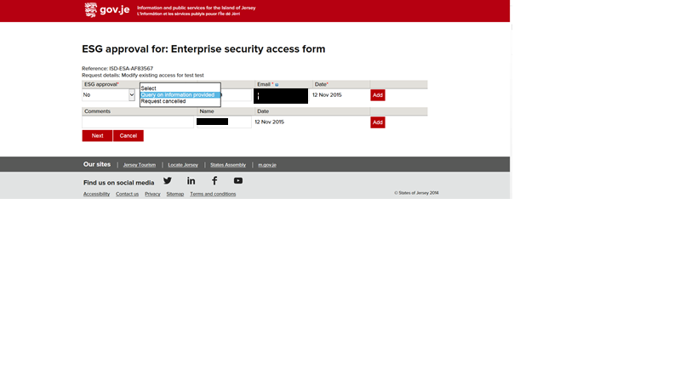

Example of No – Query on information (below) enquiry

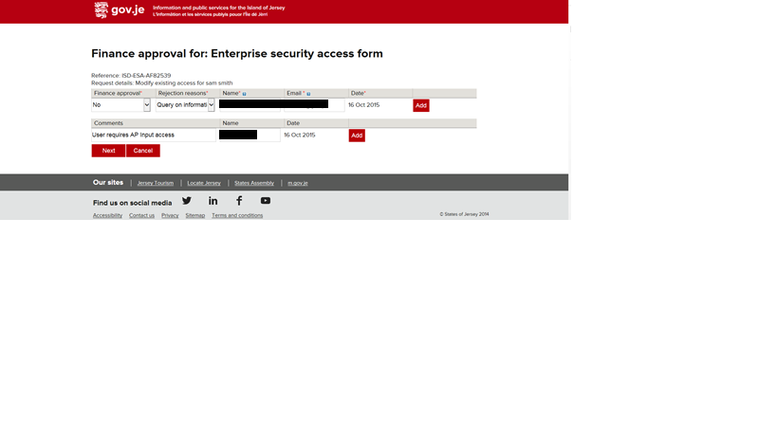

Example of No – Request cancelled (below)

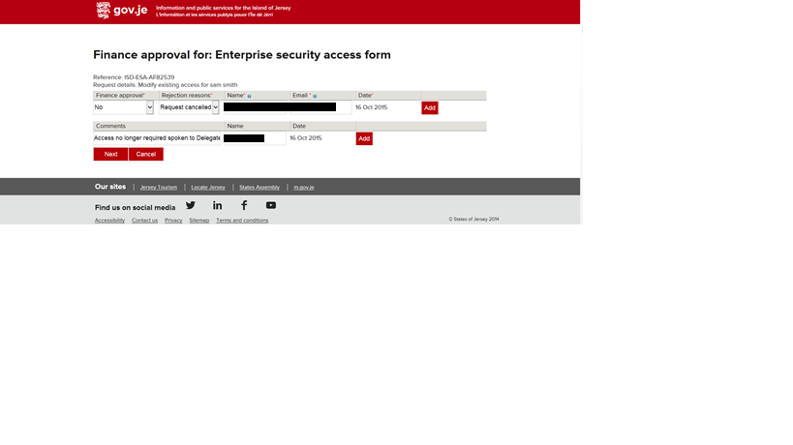

Example of Request cancelled submit page

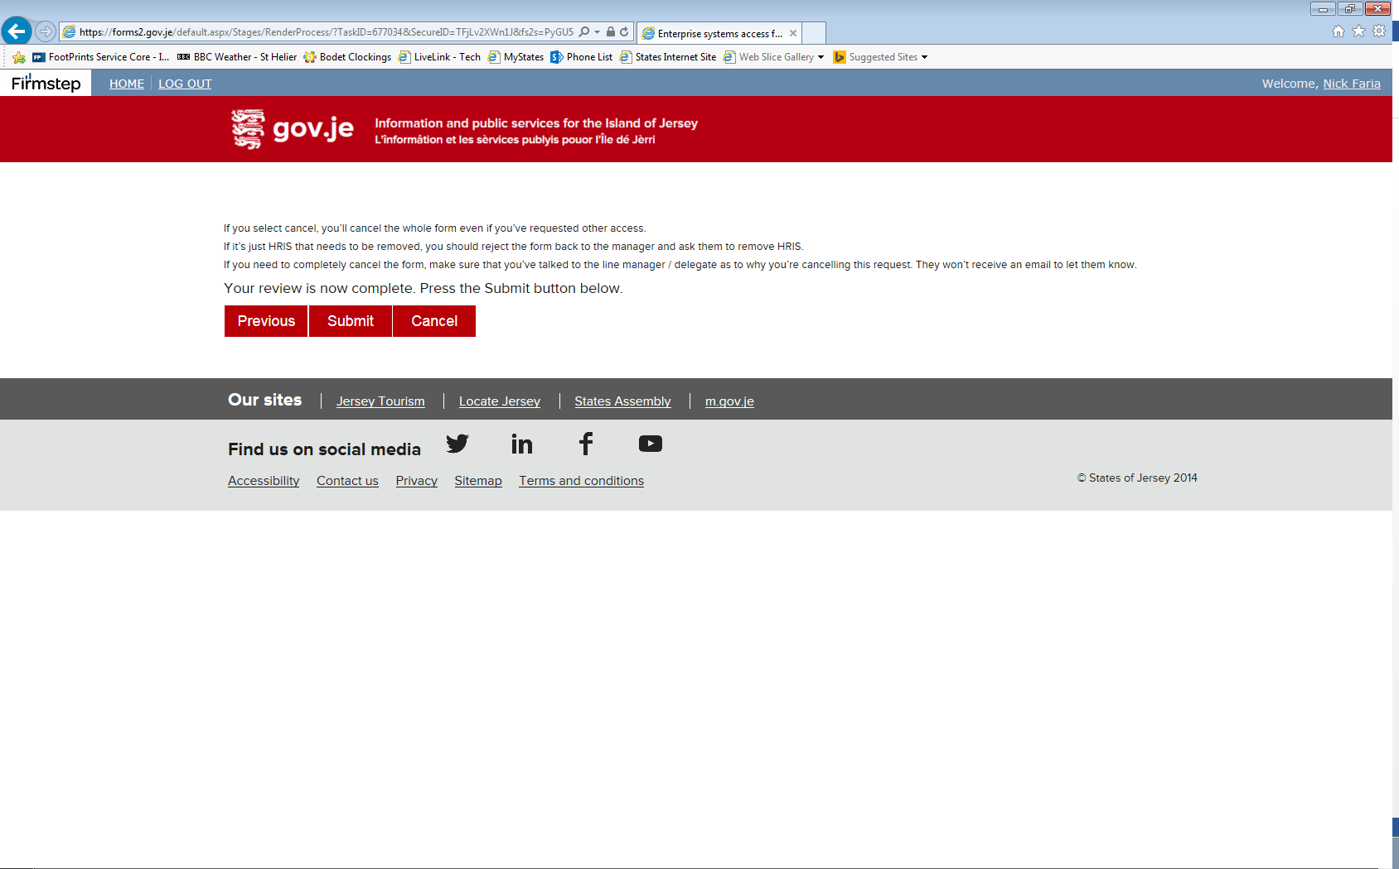

**Forward the form to the Supply Jersey team if access requested.**

Once complete, put a green tick next to the email on the ESG Security group so the team know it has been dealt with:-

